# India General Elections Result Analysis 2024

## Total number of seats.

## Query -

| SELECT  COUNT(DISTINCT Parliament_Constituency) AS Total_Seats  FROM  constituencywise_results; |
| --- |

**Output -**

## 

## Explanation of Result

The query calculates the total number of unique parliamentary constituencies by counting distinct values in the Parliament_Constituency column from the constituencywise_results table. The result represents the total number of seats available across all constituencies.

## What is the total number of seats available for elections in each state?

## Query -

| SELECT  s.State AS State_Name,  COUNT(cr.parliament_constituency) AS Total_Seats  FROM  constituencywise_results cr  INNER JOIN  statewise_results sr ON cr.Parliament_Constituency = sr.Parliament_Constituency  INNER JOIN  states s ON sr.State_ID = s.State_ID  GROUP BY s.State; |
| --- |

**Output -**

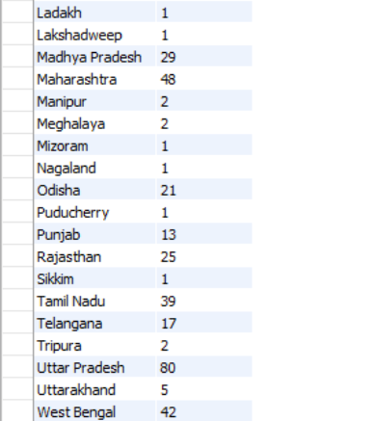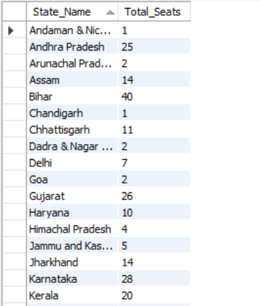

## Explanation of Result

The query calculates the total number of parliamentary constituencies (seats) for each state. It does this by joining the constituencywise_results, statewise_results, and states tables using the Parliament Constituency and State ID fields. After establishing these relationships, it groups the data by state and counts the number of constituencies in each, returning the result as Total_Seats for every State_Name.

## Total Seats Won by NDA Alliance

## Query -

| SELECT  SUM(CASE  WHEN  party IN ('Bharatiya Janata Party - BJP' ,  'Telugu Desam - TDP',  'Janata Dal (United) - JD(U)',  'Shiv Sena - SHS',  'AJSU Party - AJSUP',  'Apna Dal (Soneylal) - ADAL',  'Asom Gana Parishad - AGP',  'Hindustani Awam Morcha (Secular) - HAMS',  'Janasena Party - JnP',  'Janata Dal (Secular) - JD(S)',  'Lok Janshakti Party(Ram Vilas) - LJPRV',  'Nationalist Congress Party - NCP',  'Rashtriya Lok Dal - RLD',  'Sikkim Krantikari Morcha - SKM')  THEN  Won  ELSE 0  END) AS NDA_Total_Seats_Won  FROM  partywise_results; |
| --- |

**Output -**  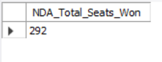

## 

## Explanation of Result

The query calculates the total number of seats won by the **NDA alliance** by summing the Won values for a list of specific political parties. It uses a CASE statement to check if each party belongs to the NDA and adds the corresponding Won value to the total if it does, or 0 if it doesn't. The result is returned as a single value under the alias NDA_Total_Seats_Won, sourced from the partywise_results table.

## 

## Total Seats Won by I.N.D.I.A Alliance

## Query-

| SELECT  SUM(CASE  WHEN  party IN ('Indian National Congress - INC',  'Aam Aadmi Party - AAAP',  'Samajwadi Party - SP',  'All India Trinamool Congress - AITC',  'Dravida Munnetra Kazhagam - DMK',  'Communist Party of India (Marxist) - CPI(M)',  'Communist Party of India - CPI',  'Communist Party of India (Marxist-Leninist) (Liberation) - CPI(ML)(L)',  'Indian Union Muslim League - IUML',  'Jammu & Kashmir National Conference - JKN',  'Jharkhand Mukti Morcha - JMM',  'Kerala Congress - KEC',  'Marumalarchi Dravida Munnetra Kazhagam - MDMK',  'Nationalist Congress Party Sharadchandra Pawar - NCPSP',  'Rashtriya Janata Dal - RJD',  'Revolutionary Socialist Party - RSP',  'Shiv Sena (Uddhav Balasaheb Thackrey) - SHSUBT',  'Viduthalai Chiruthaigal Katchi - VCK',  'Aazad Samaj Party (Kanshi Ram) - ASPKR')  THEN  Won  ELSE 0  END) AS INDIA_Total_Seats_Won  FROM  partywise_results; |
| --- |

**Output -**

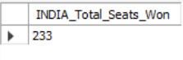

**Explanation of Result**

The query calculates the total number of seats won by the **INDIA alliance** by summing the Won values **only for parties not included** in the specified NDA party list. It uses a CASE statement to assign 0 to all NDA parties and retains the original Won values for all others. The result, labeled as INDIA_Total_Seats_Won, is retrieved from the partywise_results table and represents the total seats won by non-NDA parties.

## Number of Seats Won by I.N.D.I.A Alliance Parties

## Query -

| SELECT  party, won  FROM  partywise_results  WHERE  party IN ('Indian National Congress - INC' ,  'Aam Aadmi Party - AAAP',  'Samajwadi Party - SP',  'All India Trinamool Congress - AITC',  'Dravida Munnetra Kazhagam - DMK',  'Communist Party of India (Marxist) - CPI(M)',  'Communist Party of India - CPI',  'Communist Party of India (Marxist-Leninist) (Liberation) - CPI(ML)(L)',  'Indian Union Muslim League - IUML',  'Jammu & Kashmir National Conference - JKN',  'Jharkhand Mukti Morcha - JMM',  'Kerala Congress - KEC',  'Marumalarchi Dravida Munnetra Kazhagam - MDMK',  'Nationalist Congress Party Sharadchandra Pawar - NCPSP',  'Rashtriya Janata Dal - RJD',  'Revolutionary Socialist Party - RSP',  'Shiv Sena (Uddhav Balasaheb Thackrey) - SHSUBT',  'Viduthalai Chiruthaigal Katchi - VCK',  'Aazad Samaj Party (Kanshi Ram) - ASPKR')  ORDER BY won DESC; |
| --- |

**Output -**

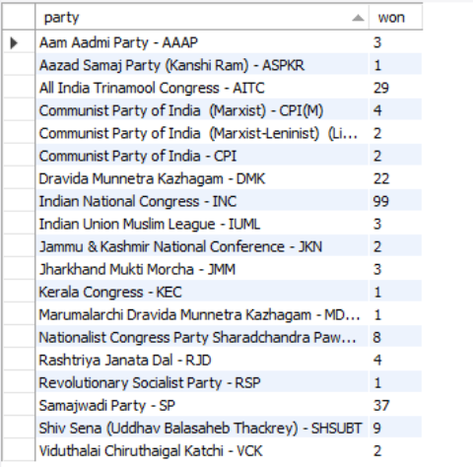

**Explanation of Result**

This query retrieves the number of seats won by parties belonging to the I.N.D.I.A alliance from the partywise_results table. It filters the results to include only the specified alliance parties and sorts them in descending order based on seats won.

* **Add a new column field in the table partywise_results to get the party allianz as NDA, I.N.D.I.A and Others.**

**Query -**

| ALTER TABLE partywise_results  ADD COLUMN party_alliances VARCHAR(50);  -- I.N.D.I.A Alliance  UPDATE partywise_results  SET  party_alliance = 'I.N.D.I.A'  WHERE  party IN ('Indian National Congress - INC' ,  'Aam Aadmi Party - AAAP',  'Samajwadi Party - SP',  'All India Trinamool Congress - AITC',  'Dravida Munnetra Kazhagam - DMK',  'Communist Party of India (Marxist) - CPI(M)',  'Communist Party of India - CPI',  'Communist Party of India (Marxist-Leninist) (Liberation) - CPI(ML)(L)',  'Indian Union Muslim League - IUML',  'Jammu & Kashmir National Conference - JKN',  'Jharkhand Mukti Morcha - JMM',  'Kerala Congress - KEC',  'Marumalarchi Dravida Munnetra Kazhagam - MDMK',  'Nationalist Congress Party Sharadchandra Pawar - NCPSP',  'Rashtriya Janata Dal - RJD',  'Revolutionary Socialist Party - RSP',  'Shiv Sena (Uddhav Balasaheb Thackrey) - SHSUBT',  'Viduthalai Chiruthaigal Katchi - VCK',  'Aazad Samaj Party (Kanshi Ram) - ASPKR'  );  -- NDA Alliance  UPDATE partywise_results  SET  party_alliance = 'NDA'  WHERE  party IN ('Bharatiya Janata Party - BJP' ,  'Telugu Desam - TDP',  'Janata Dal (United) - JD(U)',  'Shiv Sena - SHS',  'AJSU Party - AJSUP',  'Apna Dal (Soneylal) - ADAL',  'Asom Gana Parishad - AGP',  'Hindustani Awam Morcha (Secular) - HAMS',  'Janasena Party - JnP',  'Janata Dal (Secular) - JD(S)',  'Lok Janshakti Party(Ram Vilas) - LJPRV',  'Nationalist Congress Party - NCP',  'Rashtriya Lok Dal - RLD',  'Sikkim Krantikari Morcha - SKM'  );  -- Others  UPDATE partywise_results  SET  party_alliance = 'Others'  WHERE  party_alliance IS NULL; |
| --- |

**Output -**

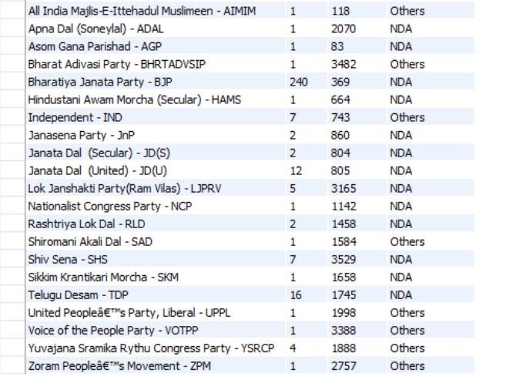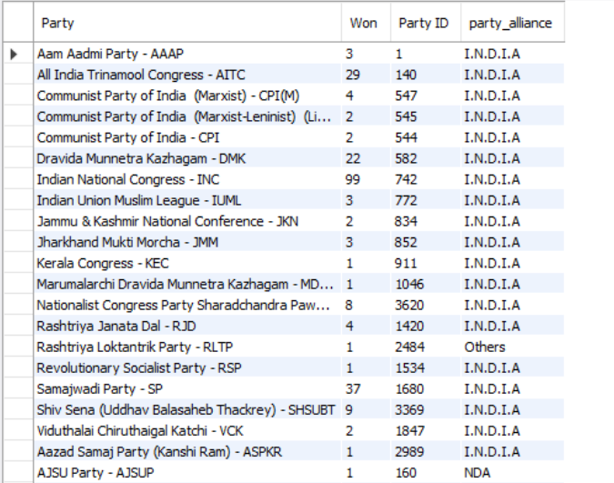

**Explanation of Result**

To categorize each party in the partywise_results table by their political alliance, a new column, party_alliance, was added using the ALTER TABLE command. Then, the UPDATE statements were used to assign the correct alliance values: **'I.N.D.I.A'**, **'NDA'**, or **'Others'**, based on which group each party belongs to. This helps in filtering and analyzing election results by alliance more efficiently.

* **Which party alliance (NDA, I.N.D.I.A, and Others) won the most seats across all states?**

**Query -**

| SELECT  party_alliance,  SUM(won) AS total_seats_won  FROM  partywise_results  GROUP BY party_alliance  ORDER BY total_seats_won DESC |
| --- |

**Output -**

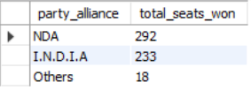

**Explanation of Result**

This query calculates the total number of seats won by each party alliance by summing the Won values for all parties grouped under each party_alliance. It then sorts the alliances in descending order of seats won, helping identify which alliance performed best overall.

* **Winning candidate’s name, their party name, total votes, and the margin of victory for a specific state constituency?**

**Query -**

| SELECT  cr.`Winning Candidate`,  pr.party,  cr.`Total Votes`,  cr.Margin,  s.state,  cr.`Constituency Name`  FROM  constituencywise_results cr  INNER JOIN  statewise_results sr ON cr.Parliament_Constituency = sr.Parliament_Constituency  INNER JOIN  partywise_results pr ON pr.`Party ID` = cr.`Party ID`  INNER JOIN  states s ON s.State_ID = sr.State_ID  WHERE  cr.`Constituency Name` = 'Basti'; |
| --- |

**Output -**

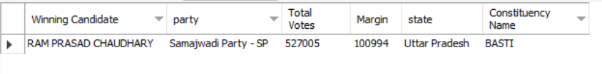

**Explanation of Result -**

This query retrieves details of the winning candidate (Winning Candidate), their party (party), total votes (total_votes), and winning margin (Margin) for the AGRA constituency (constituenct_name) by joining the tables constituencywise_results, partywise_results, and states. It helps identify the election winner and their performance in that specific seat.

* **What is the distribution of EVM votes v/s postal votes for the candidates in a specific constituency?**

**Query -**

| SELECT  `cd`.`EVM Votes`,  `cd`.`Postal Votes`,  `cd`.`Total Votes`,  `cd`.`Candidate`,  `cr`.`Constituency Name`  FROM  constituencywise_results AS `cr`  JOIN  constituencywise_details AS `cd` ON `cr`.`Constituency ID` = `cd`.`Constituency ID`  WHERE  `cr`.`Constituency Name` = 'AMETHI'; |
| --- |

**Output -**

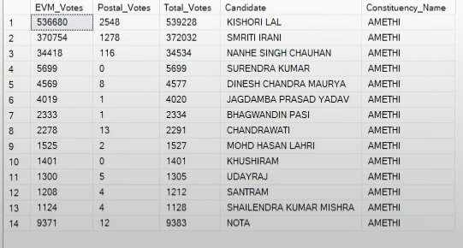

**Explanation of Result**

This query retrieves voting details (EVM Votes, Postal Votes, Total Votes) and candidate names from the constituencywise_details table, along with the constituency name from the constituencywise_results. It joins both tables using the Constituency ID. The result is filtered to show data only for the' AMETHI ' constituency.

* **Which party won the most seats in a State? How many seats did each party win?**

**Query -**

| SELECT  p.party, COUNT(cr.Parliament_Constituency) AS Seats_Won  FROM  constituencywise_results cr  JOIN  partywise_results p ON cr.`Party ID` = p.`Party ID`  JOIN  statewise_results sr ON cr.`Parliament_Constituency` = sr.`Parliament_Constituency`  JOIN  states s ON sr.`State_ID` = s.`State_ID`  WHERE  s.state = 'Uttar Pradesh'  GROUP BY p.party  ORDER BY Seats_Won DESC; |
| --- |

**Output -**

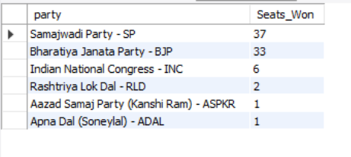

**Explanation of Result**

This query retrieves the number of seats won by each party in Uttar Pradesh from the constituencywise_results table. It joins with partywise_results, statewise_results, and states using party and constituency data. The result is filtered for the state 'Uttar Pradesh', grouped by party, and sorted by seats won in descending order.

* **What is the total number of seats won by each party alliance (NDA, I.N.D.I.A, and Others) in each state for the INDIA election of 2024.**

**Query -**

| SELECT  s.state,  SUM(CASE  WHEN pr.party_alliance = 'NDA' THEN 1  ELSE 0  END) AS 'NDA_Seats_Won',  SUM(CASE  WHEN pr.party_alliance = 'I.N.D.I.A' THEN 1  ELSE 0  END) AS 'I.N.D.I.A_Seats_Won',  SUM(CASE  WHEN pr.party_alliance = 'Others' THEN 1  ELSE 0  END) AS 'Other_Seats_Won'  FROM  constituencywise_results cr  JOIN  partywise_results pr ON cr.`Party ID` = pr.`Party ID`  JOIN  statewise_results sr ON cr.`Parliament_Constituency` = sr.`Parliament_Constituency`  JOIN  states s ON sr.`State_ID` = s.`State_ID`  GROUP BY s.state; |
| --- |

**Output -   
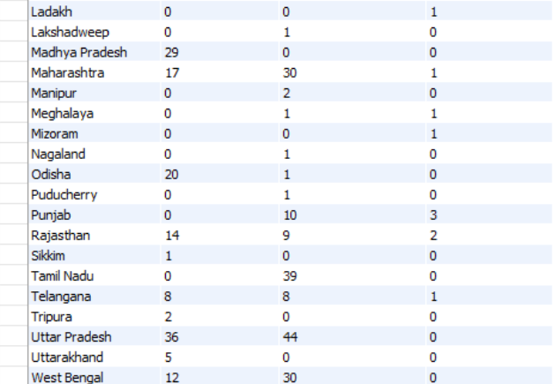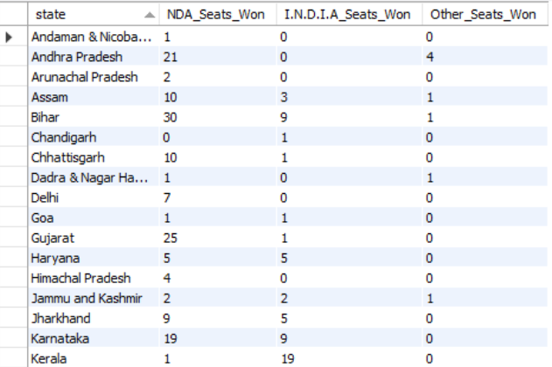**

**Explanation of Result**

This result displays the number of seats won by each political alliance — **NDA**, **I.N.D.I.A**, and **Others** — in every state. It uses data from the partywise_results, constituencywise_results, statewise_results, and states tables, grouped by **state**. The columns **NDA_Seats_Won**, **I.N.D.I.A_Seats_Won**, and **Other_Seats_Won** represent the count of constituencies won by each alliance per state.

* **Which candidate received the highest number of EVM votes in each constituency (Top 10)?**

**Query -**

| SELECT  cr.`Constituency Name`,  cd.`Constituency ID`,  cd.`Candidate`,  cd.`EVM Votes`  FROM  constituencywise_details cd  JOIN  constituencywise_results cr ON cd.`Constituency ID` = cr.`Constituency ID`  WHERE  cd.`EVM Votes` = (SELECT  MAX(cd1.`EVM Votes`)  FROM  constituencywise_details cd1  WHERE  cd1.`Constituency ID` = cd.`Constituency ID`)  ORDER BY cd.`EVM Votes` desc  LIMIT 10; |
| --- |

**Output -**

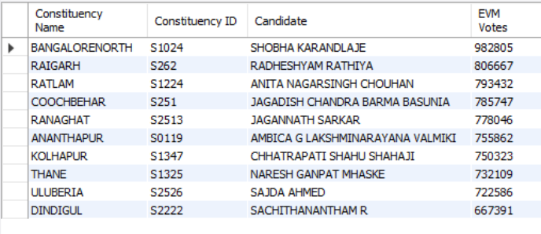

**Explanation of Result**

This result displays the top 10 candidates who received the highest number of **EVM votes** across all constituencies. It joins constituencywise_details with constituencywise_results using the **Constituency ID**, and filters to show only those candidates who secured the **maximum EVM votes in their respective constituencies**. The final result is sorted in descending order of EVM votes.

* **For the state of Maharashtra, what are the total number of seats, candidates, parties, votes (including EVM and postal), and the breakdown of EVM and postal votes?**

**Query -**

| SELECT  COUNT(DISTINCT cr.`Constituency ID`) AS Total_Seats,  COUNT(DISTINCT cd.`Candidate`) AS Total_Candidates,  COUNT(DISTINCT p.`Party`) AS Total_Parties,  SUM(cd.`EVM Votes` + cd.`Postal Votes`) AS Total_Votes,  SUM(cd.`EVM Votes`) AS Total_EVM_Votes,  SUM(cd.`Postal Votes`) AS Total_Postal_Votes  FROM  constituencywise_results cr  JOIN  constituencywise_details cd ON cr.`Constituency ID` = cd.`Constituency ID`  JOIN  statewise_results sr ON cr.`Parliament_Constituency` = sr.`Parliament_Constituency`  JOIN  states s ON sr.`State_ID` = s.`State_ID`  JOIN  partywise_results p ON cr.`Party ID` = p.`Party ID`  WHERE  s.State = 'Maharashtra'; |
| --- |

**Output -**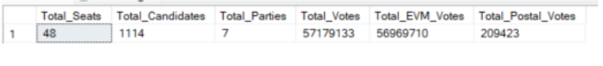

**Explanation of Result**

This result displays overall election statistics for the state of Maharashtra. It joins constituencywise_details, constituencywise_results, statewise_results, states, and partywise_results using relevant keys like Constituency ID and State ID. The query calculates the total number of constituencies (Total_Seats), candidates (Total_Candidates), and parties (Total_Parties), along with the sum of EVM (Total_EVM_Votes) and postal votes (Total_Postal_Votes). The final output is filtered to include data only for Maharashtra.